**CAT Collection**

*As can be seen in the works below, cats have played an important part in the arts, and in our daily lives. They are in our homes, porches, and imaginations. Regal, silky, purring, and wonderful.*

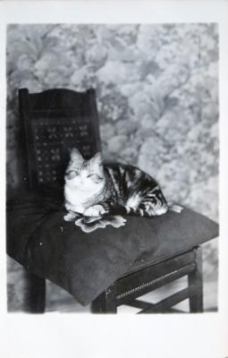

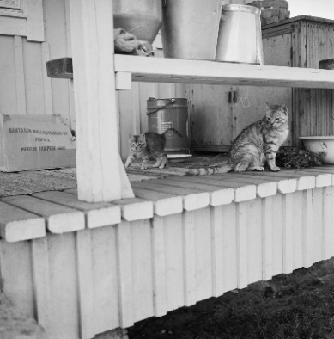

“ OB-SERVE the Cat up-on this page.

Phil-os-o-phers in ev-er-y age,

The ver-y wis-est of the wise,

Have tried her mind to an-a-lyze

In vain, for noth-ing can they learn.

She baf-fles them at ev-er-y turn

Like Mis-ter Ham-let in the play.”

Or yarn or any roll-ing thing.

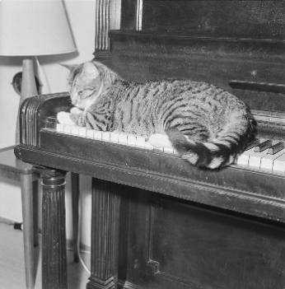 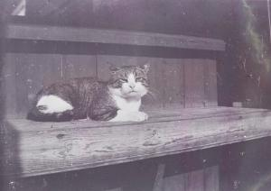

Images:

Top left: [Kissa pentuineen leikkii talon portailla](https://museovirasto.finna.fi/Record/museovirasto.6FF71400F1D629D14757F4489DA67571?lng=en-gb) (A cat and her kitten play on the stairs); provided by [Finnish Heritage Agency](https://museovirasto.fi/en/), collection [Press Photo Archive JOKA](https://www.museovirasto.fi/en/collection-and-information-services/the_picture_collections/collections/press-photo-archive-joka), Itä-Häme; licensed under [CC BY 4.0](https://creativecommons.org/licenses/by/4.0/)

Top right: [kissa; sisäkuva](https://www.finna.fi/Record/lahdenmuseo.lkm-252187?sid=3032831104&lng=en-gb), by Toivo Rehtilä, photographer 1930-1939; provided by [Asikkalan kulttuuripalvelut](https://asikkala.fi/kulttuuri-ja-vapaa-aika/kulttuuri/kulttuuripalvelut/), collection Danielson Kalmari huvilan kuva-arkisto; licensed under [CC BY 4.0](https://creativecommons.org/licenses/by/4.0/)

Bottom left: [Sjöblomin kissa](https://www.finna.fi/Record/museovirasto.037803E4FF0C20B5272E6435EBA51C08?sid=3032821450&lng=en-gb), by István Rácz, photographer 1959; provided by [Finnish Heritage Agency](https://museovirasto.fi/en/), collection [Ethnographic Picture Collection](https://www.museovirasto.fi/en/collection-and-information-services/the_picture_collections/collections/ethnographic-picture-collection), István Rácz collection; licensed under [CC BY 4.0](https://creativecommons.org/licenses/by/4.0/)

Bottom right: [Kissa puutason päällä](https://www.finna.fi/Record/tmk.161019317656800?sid=3032856262)., by E.Ekman, photographer; provided by the [Museum Centre of Turku](https://www.turku.fi/en/culture-and-sports/turku-museum-centre), collection VSO-kokoelma; Public Domain

Poem: Oliver Herford, excerpt from [The Cat](http://www.public-domain-poetry.com/oliver-herford/cat-18500), Public Domain

**License statement**

[Cat Collection](http://extra.kansalliskirjasto.fi/finelib_julkinen/lehtilistat/CC/Attachment_1.docx) © 2023 by Terhi Manninen is licensed under CC BY 4.0. To view a copy of this license, visit <http://creativecommons.org/licenses/by/4.0/>